Задание 1

|  |  |  |  |  |  |  |  |  |  |
| --- | --- | --- | --- | --- | --- | --- | --- | --- | --- |
| M=N | Количество потоков | | | | | | | | |
| 2 | | | 4 | | 7 | | 8 | |
| T1 | T2 | S1 | T3 | S2 | T4 | S3 | T5 | S4 |
| 20000 | 3.375 | 1.711 | 1,972 | 0.905 | 3,729 | 0.521 | 6,47 | 0.457 | 7,385 |
| 40000 | 13,482 | 6,746 | 1,998 | 3,746 | 3,599 | 2,12 | 6,359 | 1,905 | 7,077 |

|  |  |  |  |  |  |  |
| --- | --- | --- | --- | --- | --- | --- |
| M=N | Количество потоков | | | | | |
| 16 | | 20 | | 40 | |
| T3 | S2 | T4 | S3 | T5 | S4 |
| 20000 | 0,235 | 14,361 | 0,187 | 18,048 | 0,18 | 18,75 |
| 40000 | 1,157 | 11,652 | 1,171 | 11,513 | 1,017 | 13,256 |

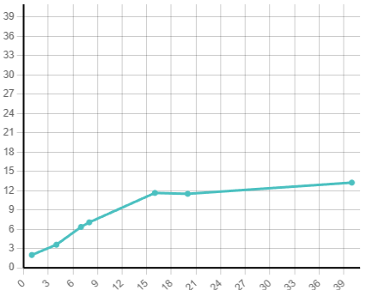

Задание 2

Наименование ЦП: Intel(R) Xeon(R) Gold 6248 CPU

Характеристики: 40 ядер, 80 потоков, тактовая частота 2.5-3.9 ГГц

Наименование сервера: ProLiant XL270d Gen10

Узлы NUMA: 2: 0-59, 20-79

node 0 size: 385636 MB

node 1 size: 387008 MB

ОС: Ubuntu 22.04.5 LTS

**omp atomic**

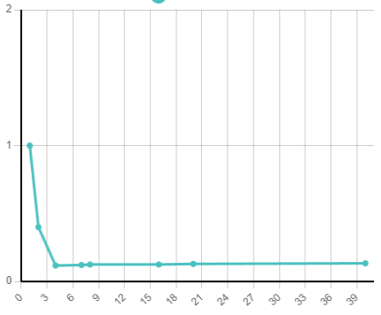

**Local variable**

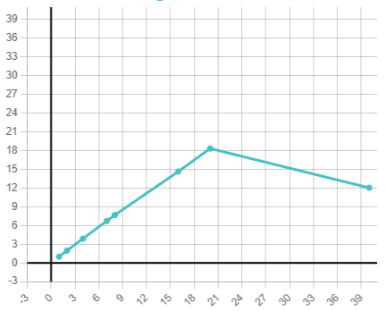

Задание 3

Один блок omp parallel

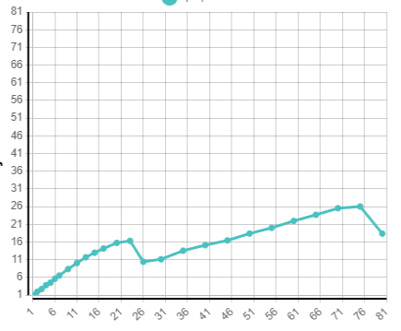

Несколько

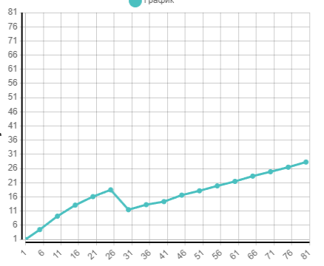

schedule(dynamic,30)